Assignment : 7
Deploy 3 repositories with 3 Diff Jobs as POLL SCM Trigger
Whnever I am doing some changes in my github Repositoies according to change in repo the job build are get RUNS
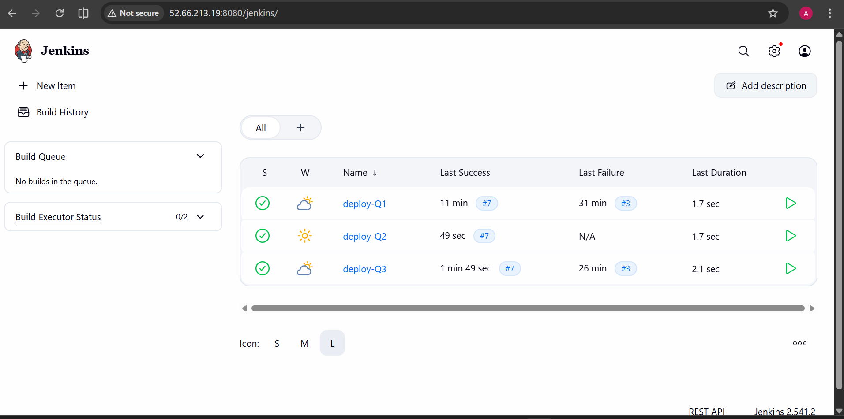
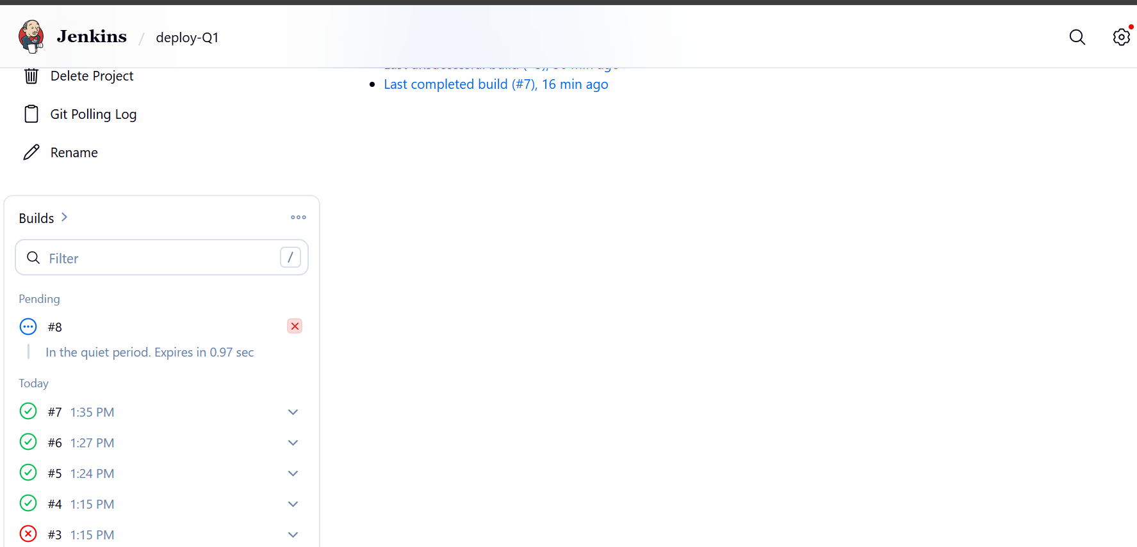
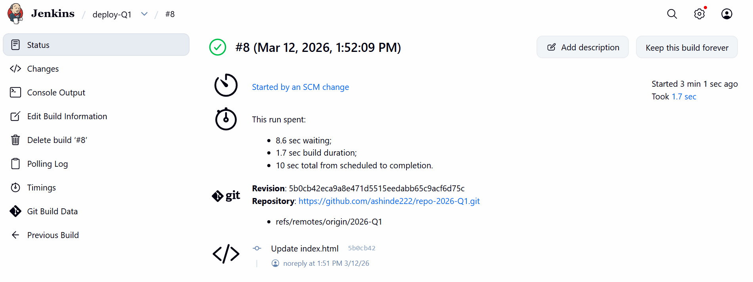

Also Same time if I am trying to access the website according to change in repo that server file I am able to see i.e. index.html
